CMP 418 – Multicore Computing
Fall 2018

Project
Name: Omar Alhammadi
ID:62027
Date: 12/12/2018

The project

The project successfully created an ECS library that utilizes OpenMP to parrallize the system. The user would specify the components classes and the systems, and then when creating an entity the user would register the various components and systems to the entity.
Then before entering the main loop, the user calls “state.init()” to sort the dependency graph of the system. After the dependencies have been sorted, the user can call “state.update()” in the main loop to update the system.

To create an EntitySystem using the ECS library, the user must create a class that inherits the EntitySystems. Additionally, the user must specify the component dependencies within the created class and override the entityUpdate() method. After doing the above, the ECS will automatically run the created system in the correct order. However, if the user adds a dependency in such a way that make the dependancy graph not a directed acyclic graph, then the system will not work.

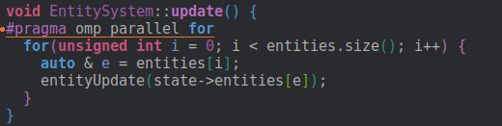
Figure 1: OpenMP used to parallelize the EntitySystem class
Finally, the project was supposed to include a job system, where any free system will run concurrently when free of dependencies. However from testing, the performance of the system decreased and became worse than a sequential system. One possible reason for such performance degradation is due to the limitation of OpenMP. Perhaps, implementing it in native threads will lead to a better results.

How to compile

To compile the project the system must have SDL2 installed:

sudo apt-get install libsdl2-2.0.0 libsdl2-dev

Then compile with:

cmake . && make

Finally, to run:

./multi

Performance Analysis

To test the performance, the program can be run with special arguments: number of threads as the first argument, the number of iterations as the second, and the number of entities as the final argument. Then, we created a test script in bash that runs the program using 1 thread to x threads, where x is specified in the script input. The script outputs a file called data.csv that run includes the frame per second numbers for each test. Then we input the data into a spreadsheet and calculate the speedup and efficiency numbers.

The following data is run on a :
- CPU: i7-8550U (4 cores, 8 threads)
- With threads ranging from 1 to 8
- Number of entities: 1 million
- Number of iterations: 10


Figure 2: Output of 100000 entities

